Vocational Training Report

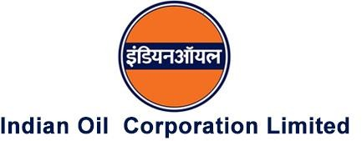

# Submitted By: Aditya Saidawat (CH-154)

**Bachelor Of Technology in Chemical Engineering**

**Duration: 15 June 2024 to 26 July 2024**



# Indian Institute of Technology Jammu

### Certificate

This is to certify that the report entitled **“Advanced Process Control Applications in Boiler Operations”** has been prepared by Mr. Aditya Saidawat, a student of B. Tech in Chemical Engineering at Indian Institute of Technology Jammu (IIT Jammu), during his internship at Indian Oil Corporation Limited (IOCL), Panipat. The internship period was from 15 June 2024 to 26 July 2024. The work contained in this report is legitimate and has been approved as his official internship report by his supervisor at the organization.

Approved By:

Date: Mr. Nikhil Anand, Process Manager (APC)

# Preface

Industrial training is pivotal in shaping future engineers, bridging the gap between academic knowledge and practical application. I had the privilege of undergoing industrial training at Indian Oil Corporation Ltd. (IOCL) in Panipat, where I gained invaluable hands-on experience.

Witnessing the operation of various units and processes firsthand was enlightening. The seamless coordination of such a large refinery to achieve its objectives was particularly impressive. With the rapid advancement of technologies, formal training in modern methods is essential for engineers to remain relevant and effective in their fields.

During my training, I came to appreciate the importance of applying theoretical concepts to real-world scenarios. This is crucial for troubleshooting and ensuring smooth production processes. The hands-on experience I acquired allowed me to develop essential industrial skills and refine my technical and professional interests in chemical engineering.

I feel fortunate to have participated in this vocational training at IOCL Panipat Refinery. This report provides an overview of my experience and the knowledge I gained. I hope this will serve as a steppingstone for my future career in chemical engineering.

# Acknowledgment

There are many individuals to whom I owe my gratitude for their contributions to the successful completion of my internship at Indian Oil Corporation Ltd. (IOCL), Panipat Refinery.

Firstly, I would like to extend my heartfelt thanks to Mr. K. Bala Murgan, Head of Department, for providing me with the opportunity to gain real-life experience working in Technical Services (PR). The series of discussions with him significantly enhanced my practical knowledge about the plant and the industry.

I would also like to express my special appreciation to my mentor, Mr. Nikhil Anand, APC Manager. His thorough guidance on control panels and tutelage during plant (TPS) site visits broadened my perspective on the workings of a refinery plant.

Furthermore, I am deeply grateful to all the employees of the refinery, including officers and staff, for their willingness to share their time and expertise during my summer training. Their detailed explanations of the processes, equipment, and various aspects of chemical engineering in the refinery were invaluable. Their kindness and support throughout the training were greatly appreciated, and their efforts to help me understand and clarify my doubts were indispensable.

I would also like to thank the Learning & Development department, especially Mr. Pankaj Tripathi, for giving me this opportunity to learn and grow within the refinery.

Lastly, I extend my gratitude to my friends and batchmates for their unwavering support throughout the internship, boosting my confidence and morale in this enriching environment.

# Index

|  |  |  |
| --- | --- | --- |
|  | **CONTENTS** | **PAGE NO.** |
| 1. | About IOCL | **6** |
| 2. | Core Values & Vision of Panipat Refinery | **7-8** |
| 3. | Panipat Refinery and Flow Diagram | **9-11** |
| 4. | Basic Working of Refinery | **12** |
| 4. | Steam Generation Infrastructure at IOCL Panipat | **13-14** |
| 6. | Very High-Pressure (VHP) Boilers at IOCL Panipat Refinery  a. Process Description   * Air and Flue Gas Path * Water Path   b. Steam Scavenging  c. Difference Between Firing and Non-Firing in HRSG  d. Fuel Usage in Boiler at IOCL Panipat Refinery  e. Thermowell Pads: Usage and Drawback at Refinery  f. Hydrocarbon Detection  g. Fuel Sampling and Calorific Value Analysis  h. Strategies for Minimizing Boiler Losses | **15-34** |
| 7. | Basic Process Control | **34-36** |
| 8. | Advanced Process Control (APC) in Boiler  a. Design/Selection of APC parameters, Model Matrix  b. Proposed network Architecture | **36-43** |
| 9. | Steps for Advanced Process Control (APC) Implementation | **43-46** |
| 10. | Functional Design Specification (FDS Of APC) | **47-48** |
| 11. | Data Analysis and Visualization of Boiler Operational Parameters | **48-53** |
| 12. | APC Benefit estimation  a. Methodologies  b. Selected methodologies for APC in boilers | **53-55** |
| 13. | Potential benefits (XIRR, IRR) and Limitations | **56-57** |
| 14. | Conclusion | **58** |

**About IOCL**

Indian Oil Corporation Limited (IOCL), commonly known as Indian Oil, stands as a cornerstone of India's energy sector and the largest commercial oil company in the country. Established in 1959 and headquartered in New Delhi, IOCL operates as a state-owned enterprise under the administrative control of the Ministry of Petroleum and Natural Gas, Government of India. It plays a crucial role in ensuring the nation’s energy security by spanning the entire hydrocarbon value chain, including refining, pipeline transportation, marketing of petroleum products, and exploration and production of crude oil and natural gas. With 11 refineries and a refining capacity of 80.75 (including CPCL) million metric tons per annum (MMTPA), Indian Oil has approval to further enhance this capacity to 87.9 MMTPA. The Indian Oil Group accounts for approximately 31% of the national refining capacity.

Beyond its robust operations in refining and distribution, IOCL is a leader in petrochemicals, lubricants, and alternative energy solutions. The company's extensive product portfolio includes everyday fuels like petrol, diesel, LPG, and aviation turbine fuel. Additionally, IOCL offers a range of specialized products under its Servo brand of lubricants, catering to automotive and industrial needs. The company’s subsidiaries, such as Chennai Petroleum Corporation Limited (CPCL), Sri Lanka, Mauritius, and the UAE, further enhance its operational capabilities and international reach.

Indian Oil is committed to sustainability and innovation, investing heavily in renewable energy projects, including wind and solar power, and consistently working to reduce its carbon footprint. Through its diverse initiatives and a strong focus on research and development, IOCL continues to drive forward, contributing significantly to India’s economic growth and development. Its dedication to corporate social responsibility, with healthcare, education, and community development initiatives, underscores its role as a responsible corporate citizen.

# Vision

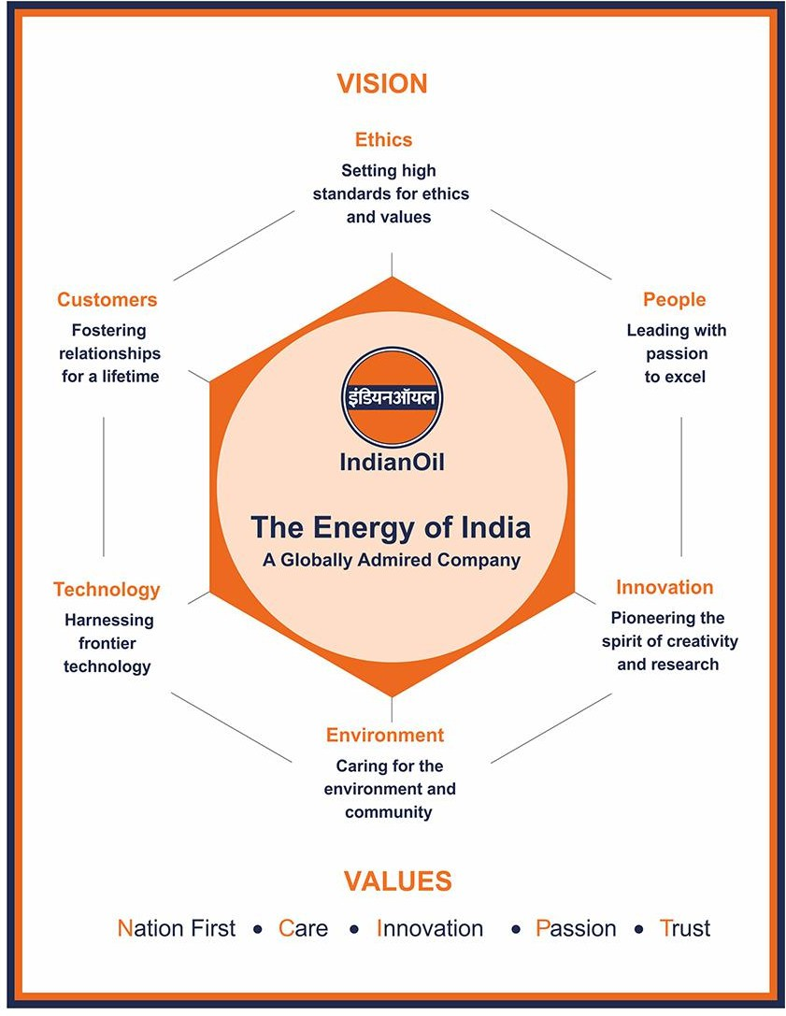

**Core Values**



**Panipat Refinery**

Panipat Refinery, commissioned in July 1998, is one of the most technically advanced public sector refinery complexes in India. Located in the historic district of Panipat in Haryana, it is the largest integrated Refinery and Petrochemical hub in India and the third largest in Southeast Asia. The complex includes a Refinery, an Aromatics Complex for Paraxylene (PX) and Purified Terephthalic Acid (PTA), and an Olefinic complex featuring a Naphtha Cracker.

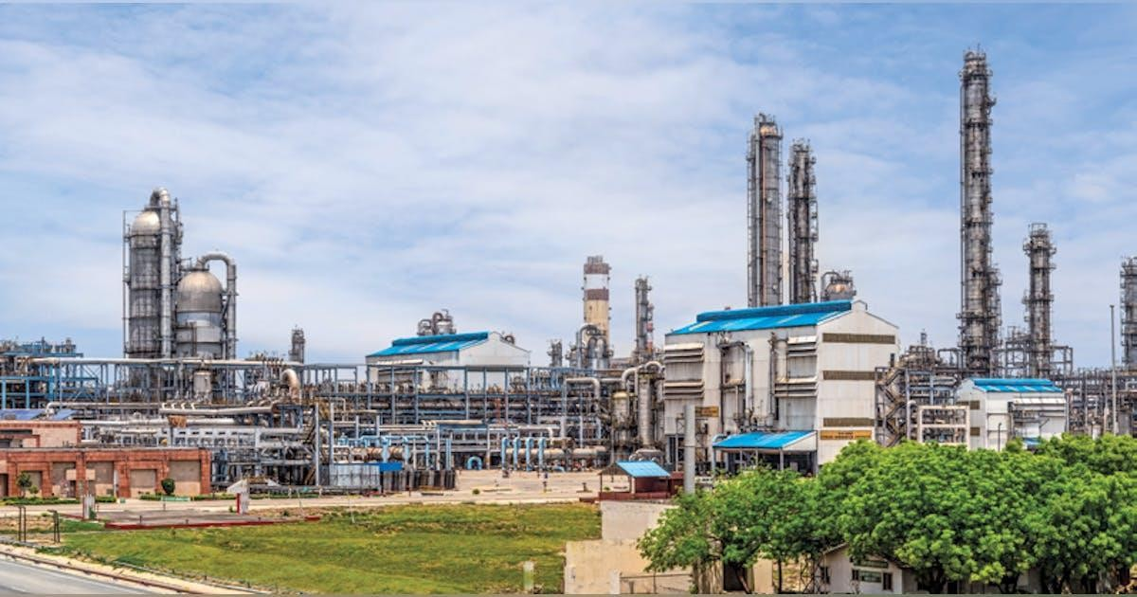

Initially, the refinery had an installed capacity of 6.0 MMTPA. To address the growing demand for petroleum products, its capacity was expanded to 12 MMTPA in 2006 and further increased to 15 MMTPA in 2010. Currently, an expansion project is underway to further increase the refinery's capacity from 15 MMTPA to 25 MMTPA. The major secondary units include a Hydrocracking Unit (HCU), Delayed Coking Unit (DCU), Diesel Hydrotreating Unit (DHDT), Hydrogen Generation Unit (HGU), Sulphur Block, and associated auxiliary facilities. The Panipat Refinery Additional Expansion Project (PRAEP) utilized a low-cost approach by maximizing the use and revamp of existing units and facilities, which included capacity enhancements of the OHCU, DCU, and ARU units.

Indian Oil solidified its position as a leading petrochemical producer in India with the commissioning of the country’s largest PTA plant. The PTA Unit at Panipat Refinery,

equipped with state-of-the-art technology, was launched in mid-2006. The integrated PX-PTA project was established to produce 360 TMT (Thousand Metric Tonnes) of Paraxylene annually and 553 TMT of PTA annually, utilizing Naphtha from both Mathura and Panipat Refineries. Paraxylene, an intermediate product, is used in the production of Polyester Staple Fibre (PSF), Polyester Filament Yarn (PFY), and other resins. The refinery exemplifies effective stream sharing with its Cracker and Aromatic complexes, where the symbiotic exchange of streams like Naphtha, Propylene, C7-C8, C4, and Hydrogen yields economic benefits for the entire complex.

The major products of Panipat Refinery include LPG, Benzene, Motor Spirit (BS-VI), Ethanol Blended Motor Spirit (EBMS), High-Speed Diesel (BS-VI), All Weather Grade (AWG) Diesel, Propylene, Para-Xylene, Purified Terephthalic Acid (PTA), Naphtha, Petcock, Sulphur, Furnace Oil (FO), and Bitumen, among others.

**Key Units of Panipat refinery:**

* Atmospheric & Vacuum Unit (AVU)
* VGO Hydrotreater Unit
* Hydrocracker Unit (HCU)
* Fluidized Catalytic Cracking Unit (FCCU)
* Delayed Coker Unit (DCU)
* Vis-breaker Unit
* Hydrogen Generation Unit (HGU)
* Diesel Hydrotreater Unit (DHDT)
* Diesel Hydrodesulphurization Unit (DHDS)
* Naphtha Hydrotreater Unit (NHTU)
* Isomerization Unit
* Gasoline Desulphurization Unit
* Catalytic Reforming Unit (CRU)
* 2G Ethanol
* 3G Ethanol
* TAME

# Panipat Refinery Flow Diagram

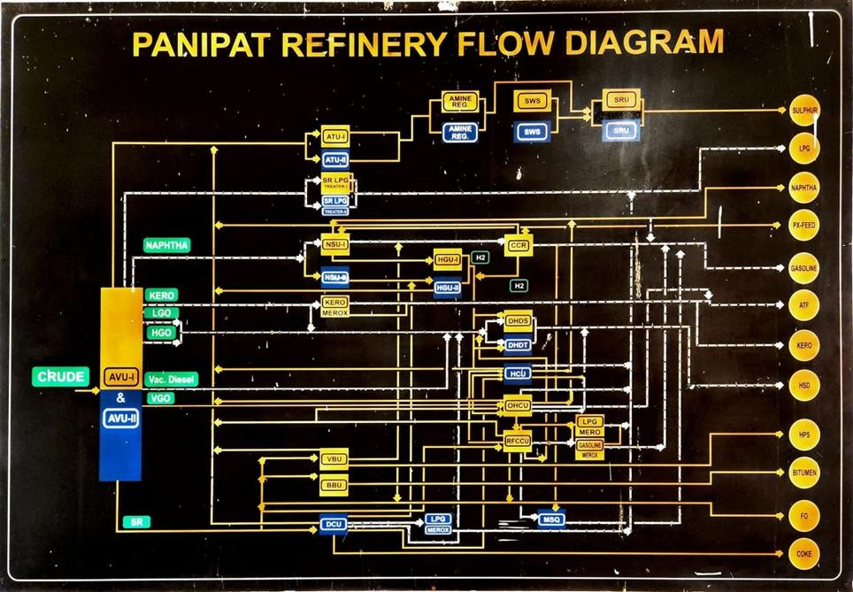

### Environmental Upgrades:

* Panipat Refinery was the first Indian Oil refinery to switch from BS-II/BS-III fuels to more eco-friendly BS III / IV fuels.
* The MSQ project, completed in December 2009, enabled the production of BS III / IV quality MS (motor spirit) by upgrading facilities like PENEX (Isomerization), Naphtha Hydrotreater Unit, and FCC Gasoline Desulphurization.
* The refinery has continued its environmental commitment with subsequent projects, including BS VI fuel production and other sustainability initiatives.

### Recent Development

The Panipat Refinery expansion project has been approved by IOCL’s Board, increasing the capacity from 15 to 25 million tons. The completion schedule for this expansion has been extended to December 2025. Engineers India Ltd (EIL) is providing consultancy and management services for this expansion project3.

**Basic Working of Refinery**

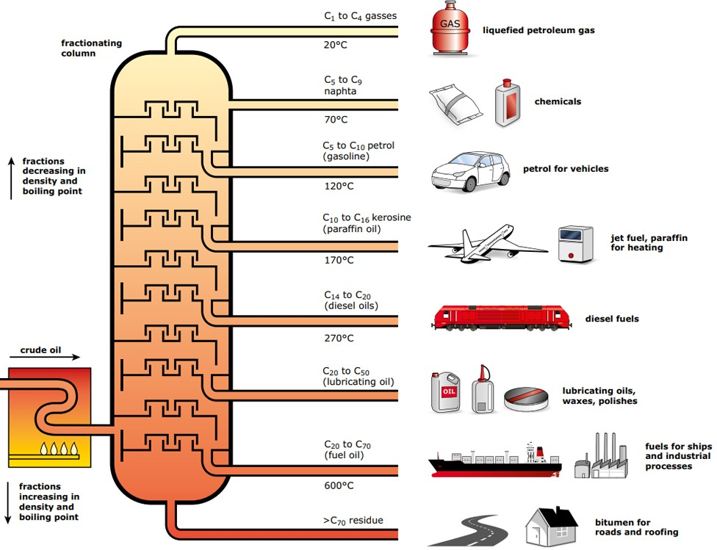

Some economically viable chemicals refined from crude oil include -

* Liquified Petroleum Gas (LPG)
* High-Speed Diesel (HSD)
* Aviation Turbine Fuel (ATF)
* Gasoline
* Kerosene
* Paraffin
* Heavy Fuel Oil
* Bitumen
* Lubricants
* 2G Ethanol

**Steam Generation Infrastructure at IOCL Panipat Refinery**

The IOCL Panipat Refinery's boiler infrastructure is meticulously designed to support its complex and energy-intensive operations. This system includes utility boilers, Heat Recovery Steam Generators (HRSG), and Very High-Pressure (VHP) boilers, each playing a crucial role in ensuring a reliable supply of steam at various pressures and temperatures, thereby optimizing energy use and process efficiency.

1. **Utility Boilers:**
2. The refinery operates two utility boilers with the following specifications:

* **Flow Rate**: 230 tons per hour (TPH)
* **Pressure**: 40 kg/cm²
* **Temperature**: 400°C

1. These utility boilers provide the necessary steam for various plant operations and utility needs. They are essential for maintaining operational continuity by supplying steam for general processes and ancillary requirements.
2. **Heat Recovery Steam Generators (HRSG):**

The refinery employs five HRSG units to enhance energy efficiency:

1. **HRSG1**:
   * **Flow Rate**: 127 TPH
   * **Pressure**: 16 kg/cm²
   * **Temperature**: 315°C
2. **HRSG2, HRSG3, HRSG4, and HRSG5**:
   * **Flow Rate**: 110 TPH each
   * **Pressure**: 40 kg/cm²
   * **Temperature**: 400°C
3. **Supplementary Firing**:
   * **Pressure**: 17 kg/cm²
   * **Temperature**: 300°C

These HRSG units recover waste heat from process gases, significantly improving overall energy efficiency and reducing fuel consumption. By capturing and repurposing waste heat, these units contribute to the sustainability and cost-effectiveness of refinery operations.

1. **Very High-Pressure (VHP) Boilers:**

The refinery also operates three VHP boilers with the following specifications:

* **Flow Rate**: 160 TPH each
* **Pressure**: 104 kg/cm²
* **Temperature**: 610°C

These VHP boilers are essential for providing high-pressure steam required for various high-energy processes within the refinery. The robust design and high efficiency of these boilers ensure they meet the stringent demands of the refinery’s processes, contributing to overall plant efficiency and reliability.

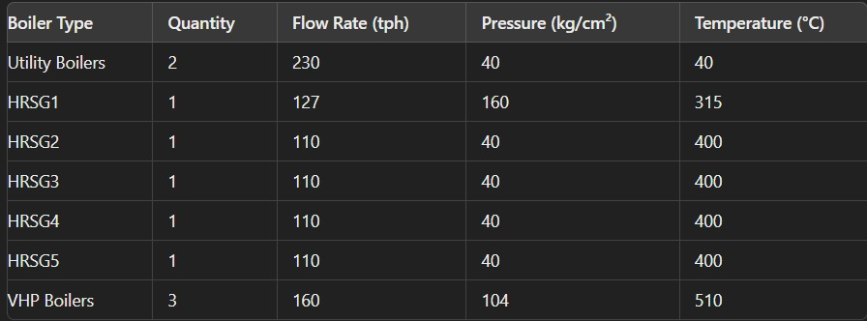



**Very High-Pressure Boiler:**

The Very High Pressure (VHP) boilers at the Indian Oil Corporation Limited (IOCL) refinery are pivotal to maintaining efficient and continuous operations by providing reliable steam and power. These boilers are integral components of the Captive Power Plant (CPP), which ensures an autonomous and steady supply of energy to the refinery.

1. **Boiler and Generator Configuration:**
   1. **Units Configuration**:

The Captive Power Plant (CPP) at the IOCL refinery is equipped with three VHP steam generators and three turbo generators.

* 1. **Turbo Generators**:

Each turbo generator, manufactured by **Bharat Heavy Electricals Limited (BHEL),** boasts an installed capacity of **25 MW**. These generators effectively convert thermal energy from steam into electrical energy, ensuring a consistent power supply.

* 1. **Superheated Steam Input**:

The boilers provide superheated steam at a rate of **160 tons per hour (TPH),** with an operational pressure of **104 kg/cm²** and a temperature of **510°C**. This high-pressure, high-temperature steam is critical for driving the turbo generators, ensuring optimal performance and efficiency.

1. **Boiler Specifications:**
   1. **Manufacturer**:

The VHP boilers are manufactured by BHEL, a leading industrial equipment manufacturer known for reliability and high performance.

* 1. **Design Features**:

These boilers incorporate a bi-drum design, featuring two drums connected by bank tubes, facilitating efficient heat exchange and steam generation.

* 1. **Natural Circulation**:

The boilers employ a natural circulation system, leveraging the density difference between steam and water to circulate water without the need for pumps, thus enhancing reliability and reducing maintenance requirements.

* 1. **Balanced Draft System**:

The boilers operate with a balanced draft system, utilizing both induced draft (ID) and forced draft (FD) fans to maintain proper air and gas flow. This system ensures efficient combustion and optimal boiler performance.

* 1. **Fuel Flexibility**:

Capable of being fired with heavy furnace oil (HFO), light diesel oil (LDO), or refinery gas, these boilers offer significant operational flexibility. This capability allows the refinery to utilize the most economical and available fuel sources.

* 1. **Advanced Burners**:

Each boiler is equipped with six sets of oil/gas combination burners. These burners are designed to ensure efficient and complete combustion of the fuel, which is crucial for achieving high thermal efficiency and minimizing emissions.

**Air and Flue Gas Path (100%MCR):**

**Detailed Air Path in Boiler Systems**

**1. Introduction:**

As a chemical engineer, understanding the air path in boiler systems is crucial for optimizing combustion efficiency, heat transfer, and overall boiler performance. This report provides a detailed explanation of the air path, highlighting each component's role and the technical considerations involved in maintaining high boiler efficiency.

**2. Air Path Components:**

1. **Air Inlet and Forced Draft Fan (FDF):**
   1. **Air Inlet:** Ambient air is drawn into the boiler system through the air inlet. The air quality and temperature significantly impact combustion efficiency, making it essential to ensure that the air is clean and within the optimal temperature range.
   2. **Forced Draft Fan (FDF):** The FDF is responsible for pushing the air through the system. It ensures a controlled and constant airflow, which is critical for maintaining stable combustion. The fan's performance directly affects air distribution and pressure within the system, influencing the overall combustion process.
2. **Steam Coiled Air Preheater (SCAPH):**
   1. **Function:** The SCAPH preheats incoming air by passing it over finned tubes containing steam, thereby increasing the air temperature before it enters the rotary air preheater.
   2. **Benefits:** Preheating the air reduces the risk of cold end corrosion in the rotary air preheater and improves overall thermal efficiency by utilizing waste heat from the steam.
3. **Rotary Air Preheater:**
   1. **Heat Transfer Elements:** The rotary air preheater contains heat transfer elements that absorb heat from the exiting flue gas and transfer it to the incoming air.
   2. **Process:** Preheated air from the SCAPH enters the rotary air preheater, gaining additional heat from the flue gases. The highly preheated air exits the rotary air preheater and is directed to the furnace.
   3. **Impact:** Maximizing heat recovery from the flue gases in this stage is essential for improving combustion efficiency and reducing fuel consumption.
4. **Furnace:**
   1. **Combustion Process:** In the furnace, highly preheated air mixes with fuel at the burners, where combustion occurs. The quality of the air-fuel mixture is crucial for achieving efficient and complete combustion.
   2. **Flue Gases:** The combustion generates high-temperature flue gases that rise through the furnace, transferring heat to the water in the furnace walls and generating steam.
   3. **Heat Transfer:** Efficient combustion and heat transfer in the furnace are vital for maintaining high boiler efficiency and minimizing fuel consumption.
5. **Superheaters:**
   1. **Primary and Secondary Superheaters:** Hot flue gases from the furnace flow over primary and secondary superheater tubes, where steam inside the tubes absorbs heat and becomes superheated steam.
   2. **Function:** Superheating the steam increases its temperature and energy content, making it suitable for driving turbines and other high-temperature applications.
   3. **Efficiency:** The performance of superheaters directly affects the overall thermal efficiency of the boiler and the quality of the steam produced.
6. **Convection Bank:**
   1. **Heat Transfer:** Remaining hot flue gases pass through the convection bank, transferring heat to the steam and water in the vertical tubes and further enhancing the boiler's thermal efficiency.
7. **Economizer:**
   1. **Function:** The economizer captures waste heat from the flue gases and transfers it to the feed water, preheating it before it enters the boiler.
   2. **Benefits:** Preheating feed water reduces the energy required to convert it into steam, thereby improving overall efficiency.
   3. **Heat Recovery:** Effective operation of the economizer is crucial for maximizing heat recovery and reducing fuel consumption.

**3. Detailed Air Path Explanation:**

**Step-by-Step Air Path:**

1. **Air Inlet and Forced Draft Fan (FDF):**
   1. Ambient air is drawn into the system.
   2. The FDF ensures a controlled and constant airflow.
2. **Steam Coiled Air Preheater (SCAPH):**
   1. Air passes over finned tubes with steam, preheating the air.
   2. Preheated air exits the SCAPH, reducing the risk of cold end corrosion.
3. **Rotary Air Preheater:**
   1. Preheated air enters the rotary air preheater.
   2. Heat transfer elements absorb heat from flue gases, further heating the air.
   3. Highly preheated air exits and is directed to the furnace.
4. **Furnace:**
   1. Preheated air mixes with fuel at the burners, initiating combustion.
   2. Combustion generates high-temperature flue gases that rise through the furnace.
   3. Flue gases heat the water in the furnace walls, producing steam.
5. **Superheaters:**
   1. Flue gases flow over primary and secondary superheater tubes.
   2. Steam inside the tubes absorbs heat, becoming superheated steam.
6. **Convection Bank:**
   1. Remaining hot flue gases pass through the convection bank.
   2. Heat is transferred to steam and water in vertical tubes, enhancing efficiency.
7. **Economizer:**
   1. Flue gases from the convection bank pass through the economizer.
   2. Heat is transferred to the feed water, preheating it before it enters the boiler.

**4. Factors Affecting Boiler Efficiency:**

1. **Fuel Quality and Type:**
   * **Impact:** Poor fuel quality or incorrect fuel type can reduce combustion efficiency, leading to higher fuel consumption and increased emissions.
   * **Improvement:** Use high-quality fuel and ensure compatibility with the burner design.
2. **Combustion Air Supply:**
   * **Impact:** Incorrect air-to-fuel ratio can lead to incomplete combustion, resulting in fuel wastage and higher emissions.
   * **Improvement:** Properly calibrate and maintain air registers, dampers, and control systems to ensure optimal air supply.
3. **Burner Performance:**
   * **Impact:** Inefficient burners can cause incomplete combustion, increased fuel consumption, and uneven heat distribution.
   * **Improvement:** Regular maintenance and tuning of burners, ensuring correct positioning of gas/oil guns and igniters.
4. **Heat Exchange Efficiency:**
   * **Impact:** Fouling of heat exchange surfaces reduces heat transfer efficiency, leading to higher fuel consumption.
   * **Improvement:** Implement effective cleaning procedures and schedule regular inspections and maintenance.
5. **Steam Drum and Internals:**
   * **Impact:** Poor separation of steam and water can lead to carryover, reducing steam quality and causing damage to downstream equipment.
   * **Improvement:** Ensure proper functioning of steam purifiers and blowdown systems to maintain steam purity.
6. **Boiler Insulation:**
   * **Impact:** Inadequate insulation leads to heat losses, reducing overall efficiency.
   * **Improvement:** Use high-quality insulation materials and regularly inspect for damage or wear.
7. **Furnace Design and Operation:**
   * **Impact:** Inefficient furnace design or operation can cause poor combustion and heat distribution, leading to higher fuel consumption.
   * **Improvement:** Optimize furnace design and operate within recommended parameters, ensuring proper flame stability and even heat distribution.
8. **Superheater and Desuperheater Performance:**
   * **Impact:** Inefficient superheaters and desuperheaters can lead to poor steam quality and reduced thermal efficiency.
   * **Improvement:** Ensure proper functioning and maintenance of superheaters and desuperheaters, and control steam temperature effectively.
9. **Economizer and Air Preheater Efficiency:**
   * **Impact:** Inefficient economizers and air preheaters can lead to heat losses, reducing overall efficiency.
   * **Improvement:** Optimize the design and operation of economizers and air preheaters, ensuring proper heat recovery and reducing flue gas temperatures.
10. **Boiler Control Systems:**
    * **Impact:** Inefficient control systems can lead to poor regulation of combustion, steam production, and heat exchange, reducing overall efficiency.
    * **Improvement:** Implement advanced control systems with real-time monitoring and automated adjustments to optimize boiler performance.
11. **Water Quality and Treatment:**
    * **Impact:** Poor water quality can lead to scaling and corrosion, reducing heat transfer efficiency and causing damage to boiler components.
    * **Improvement:** Implement effective water treatment procedures to maintain water quality and prevent scaling and corrosion.
12. **Operational Practices:**
    * **Impact:** Inefficient operational practices can lead to suboptimal boiler performance and increased fuel consumption.
    * **Improvement:** Train operators in best practices, ensure proper start-up and shut-down procedures, and regularly review operational protocols.

**5. Areas for Improvement and Potential Losses:**

* **Improvements:**
  1. **Regular Maintenance:** Prevents equipment deterioration and ensures optimal performance.
  2. **Advanced Control Systems:** Enables real-time adjustments and better regulation of combustion and heat transfer processes.
  3. **Fuel Quality Management:** Ensures consistent and efficient combustion, reducing fuel consumption and emissions.
  4. **Enhanced Insulation:** Reduces heat losses, improving overall thermal efficiency.
  5. **Effective Cleaning Procedures:** Maintains heat exchange efficiency and prevents fouling of critical components.
* **Potential Losses:**

1. **Poor Fuel-Air Ratio:** Leads to incomplete combustion, higher fuel consumption, and increased emissions.
2. **Inadequate Maintenance:** Causes equipment deterioration, reduced efficiency, and potential failures.
3. **Suboptimal Operational Practices:** Leads to inefficient boiler operation, increased fuel consumption, and reduced lifespan of components.
4. **Poor Water Quality:** Causes scaling and corrosion, reducing heat transfer efficiency and damaging boiler components.

**Water Path**

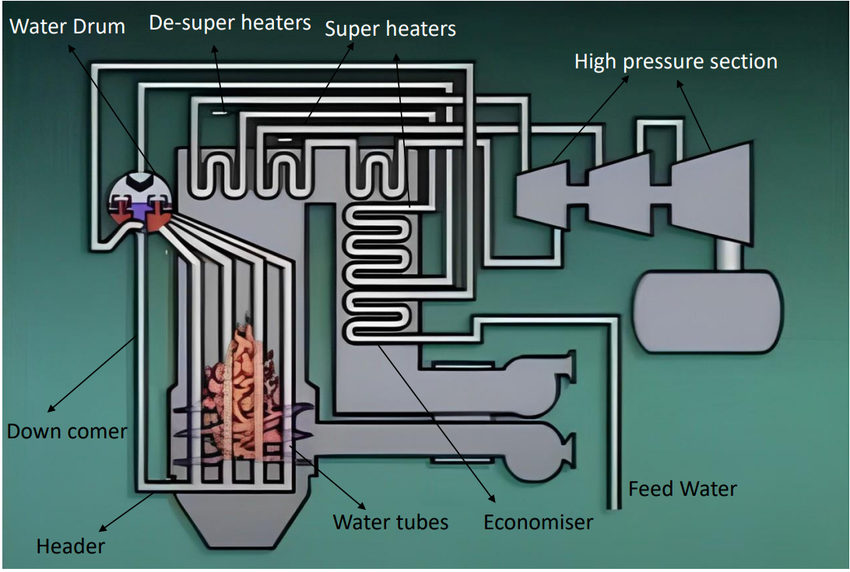

**Process Description:**

1. **Water Intake from Lake:**

* **Mechanism:**
  + Raw Water Intake Pumps: These pumps are designed to draw water from the lake and transfer it to the pre-treatment system. They are typically centrifugal pumps capable of handling large volumes of water.
* **Screening:**
  + Coarse Screens: Remove large debris like leaves, sticks, and trash.
  + Fine Screens: Capture smaller particles that pass through the coarse screens.
  + Debris Management: Collected debris is periodically removed and disposed of properly.

1. **Pre-treatment:**

**Mechanism:**

1. **Coagulation and Flocculation:**
   * Coagulation: Chemical coagulants (e.g., alum, ferric chloride) are added to destabilize suspended particles.
   * Flocculation: Gentle mixing encourages the formation of larger aggregates (flocs) from the destabilized particles.
2. **Sedimentation Tanks:**
   * Sedimentation: Water flows into sedimentation tanks where the flocs settle to the bottom by gravity.
3. **Sludge Removal:**
   * Settled sludge is removed from the bottom of the tanks.
4. **Filtration:**
   * Sand Filters: Water passes through sand filters to remove remaining suspended solids.
5. **Backwashing:**
   * Periodically, the filters are backwashed to clean and remove trapped particles.
6. **Demineralization (DM) Plant**

**Mechanism:**

1. **Ion Exchange Resins:**
   1. **Cation Exchange:** Water passes through cation exchange resin columns, where positive ions (e.g., calcium, magnesium) are exchanged for hydrogen ions (H⁺).
   2. **Anion Exchange:** Water then flows through anion exchange resin columns, where negative ions (e.g., chloride, sulfate) are exchanged for hydroxide ions (OH⁻).
   3. **Mixed Bed Resin:** A mixed bed resin can be used for final polishing, combining both cation and anion resins in a single column to achieve high purity water.
2. **Regeneration:**
3. **Cation Resin:** Regenerated with strong acid (e.g., hydrochloric acid) to replace the captured cations with hydrogen ions.
4. **Anion Resin:** Regenerated with strong base (e.g., sodium hydroxide) to replace the captured anions with hydroxide ions.
5. **Rinsing:** After regeneration, the resins are rinsed with water to remove any residual regenerant chemicals.
6. **Deaerator:**

**Mechanism:**

1. **Deaeration:**
   1. **Spray-Type Deaerator:** Water is sprayed into a steam atmosphere, breaking it into small droplets, increasing the surface area for gas removal.
   2. **Tray-Type Deaerator:** Water flows over a series of trays, again increasing the surface area for gas removal.
2. **Heating:** The water is heated close to its boiling point, which reduces the solubility of gases (primarily oxygen and carbon dioxide).
3. **Gas Venting:** The liberated gases are vented from the deaerator, typically through a vent condenser to recover any steam.
4. **Boiler Feedwater Pump:**

**Mechanism:**

1. **High-Pressure Pump:** These multistage centrifugal pumps are designed to increase the pressure of the water to the level required by the boiler.
2. **Sealing and Lubrication:** The pumps have mechanical seals and lubrication systems to ensure reliable operation and prevent leaks.
3. **Boiler:**

**Mechanism:**

1. **Water-Tube Boiler:**
   1. Feedwater Entry: High-pressure feedwater enters the boiler drum.
   2. Water Circulation: Water flows through downcomers into the lower drum and then up through the water tubes where it is heated by combustion gases.
   3. Steam Formation: As the water absorbs heat, it turns into steam, which rises to the upper drum (steam drum).
2. **Steam Drum:**
   1. Steam Separation: Steam is separated from water using cyclones, baffles, and separators.
   2. Steam Outlet: Dry steam is collected and directed to the steam turbine.
3. **Blowdown:**
   1. Continuous Blowdown: Small amounts of water are continuously removed to control the concentration of dissolved solids.
   2. Intermittent Blowdown: Periodic removal of larger quantities of water to flush out accumulated sludge and sediment.

**Steam Scavenging**

1. **Types of Steam Scavenging:**
2. **High-Pressure Steam Scavenging:**
   * **Pressure Range:** Typically above 60 bar (870 psi)
   * **Temperature Range:** Often above 250°C (482°F)
   * **Application:** Used in high-pressure boilers and turbines where the quality of steam must be extremely high to avoid erosion, corrosion, and thermal inefficiencies.
   * **Mechanism:** High-pressure steam systems often use separators, superheaters, and reheaters to remove moisture and non-condensable.
3. **Medium-Pressure Steam Scavenging:**
   * **Pressure Range:** Between 15-60 bar (218-870 psi)
   * **Temperature Range:** Between 200-300°C (392-572°F)
   * **Application:** Used in medium-pressure boilers and process heating where steam quality is important but not as critical as high-pressure applications.
   * **Mechanism:** Medium-pressure systems may use steam dryers and demisters to improve steam quality.
4. **Low-Pressure Steam Scavenging:**
   * **Pressure Range:** Below 15 bar (218 psi)
   * **Temperature Range:** Typically, below 200°C (392°F)
   * **Application:** Used in low-pressure heating, drying, and other applications where steam quality is less critical.
   * **Mechanism:** Low-pressure systems may use basic moisture separators or simpler methods to ensure steam quality.
5. **Mechanism:**

The mechanism of steam scavenging involves various methods and equipment designed to remove unwanted substances like moisture and non-condensable gases from the steam. This ensures that the steam used in applications such as turbines and heat exchangers is dry and free from impurities, which helps prevent damage to equipment and improves efficiency. Here’s a detailed explanation of the mechanisms involved in steam scavenging:

1. **Steam Separators:**

**Mechanism:**

1. **Cyclonic Separators:**

* **Operation:** Steam enters the separator tangentially, creating a cyclonic motion.
* **Separation:** The centrifugal force pushes heavier water droplets to the walls of the separator, where they collect and are drained away.
* **Outcome:** Dry steam exits from the center of the separator.

1. **Baffle-Type Separators:**

* **Operation:** Steam flows through a series of baffles.
* **Separation:** The change in direction causes water droplets to be separated from the steam as they impact the baffles and fall to the bottom.
* **Outcome:** Moisture-free steam exits the separator.

1. **Superheaters:**

**Mechanism:**

* **Operation:**
* **Steam Path:** Steam passes through tubes heated by flue gases or another heat source.
* **Heat Transfer:** The temperature of the steam is raised above its saturation point.
* **Effect:**
* **Moisture Removal:** The superheating process ensures that any residual moisture is evaporated, resulting in dry steam.
* **Increased Efficiency:** Superheated steam has higher thermal energy and efficiency, ideal for driving turbines.

1. **Demisters:**

**Mechanism:**

* **Mesh Pads:**
* **Operation:** Steam flows through a fine mesh pad made of metal or synthetic fibres.
* Separation: Moisture droplets coalesce on the fibres and form larger droplets.
* **Drainage:** The larger droplets are heavy enough to fall out of the steam flow and are drained away.
* **Outcome:** Dry steam exits the demister.

1. **Deaerators:**

**Mechanism:**

1. **Spray-Type Deaerators:**
   * **Operation:** Water is sprayed into a steam atmosphere.
   * **Gas Removal:** The fine spray increases the surface area, allowing dissolved gases to escape from the water.
   * **Outcome:** The steam heats the water, further reducing the solubility of gases and driving them off.
2. **Tray-Type Deaerators:**
   * **Operation:** Water flows over a series of trays, increasing contact with the steam.
   * **Gas Removal:** The cascading action and extended surface area allow gases to be efficiently stripped from the water.
   * **Outcome:** Heated and deaerated water collects at the bottom and is sent to the boiler
3. **Blowdown Systems:**

**Mechanism:**

1. **Continuous Blowdown:**
   * **Operation:** A controlled amount of water is continuously drained from the boiler to manage the concentration of dissolved solids.
   * **Effect:** Helps in maintaining boiler water chemistry and preventing scale formation.
2. **Intermittent Blowdown:**
   * **Operation:** Larger volumes of water are periodically drained from the boiler.
   * **Effect:** Removes sludge and sediment that settle at the bottom of the boiler, preventing buildup and maintaining efficiency.
3. **Surface Area Effect on Steam Scavenging:**
4. **Increased Surface Area:** Enhancing the surface area for heat transfer in steam systems can improve the efficiency of moisture removal. This is typically achieved by using devices like steam separators, demisters, and superheaters which provide a larger contact area for steam to interact with surfaces that can help in the separation of moisture and non-condensable gases.
5. **Steam Separators:** Use centrifugal force or baffles to increase the surface area and separate moisture from steam.
6. **Superheaters:** Heat steam above its saturation temperature, thus increasing the dryness fraction and reducing moisture content.
7. **Demisters:** Fine mesh pads or other devices that create a large surface area for steam to pass through, allowing moisture droplets to coalesce and separate out.

**Practical Implementation**

1. **Steam Separators:**
2. **High-Pressure Systems:** Use cyclonic separators or baffle-type separators to handle high pressure and temperature.
3. **Medium-Pressure Systems:** Use similar designs but tailored to handle lower pressures.
4. **Low-Pressure Systems:** Simpler designs that rely on gravity and basic separation techniques.
5. **Superheaters:**
6. **High-Pressure Systems:** Installed in the path of the flue gases to absorb maximum heat.
7. **Medium-Pressure Systems:** May use less extensive superheating stages.
8. **Low-Pressure Systems:** Often not required, but simple steam dryers may be used.
9. **Demisters:**
10. **High-Pressure Systems:** Use advanced materials and designs to ensure minimal pressure drop while maximizing efficiency.
11. **Medium-Pressure Systems:** Use conventional demisters with moderate efficiency.
12. **Low-Pressure Systems:** Basic demisters to remove large droplets.

**Difference Between Firing and Non-Firing HRSG**

1. **Non-Firing HRSG:**

* **Definition**: Utilizes waste heat from exhaust gases exclusively for steam generation without additional fuel combustion.
* **Operation**: Relies solely on exhaust gas heat recovery, requiring no additional fuel input.
* **Advantages**:
  1. **High Fuel Efficiency**: Maximizes energy recovery from exhaust gases, minimizing fuel usage.
  2. **Lower Emissions**: Reduces environmental impact by operating without additional combustion.
  3. **Simpler Design**: Streamlined system with fewer components, leading to lower maintenance requirements and operational complexity.
* **Disadvantages**:
  1. **Limited Steam Production**: Output is constrained by exhaust gas temperature and flow rate, affecting capacity.
  2. **Dependent on Exhaust Gas Conditions**: Performance hinges on consistent exhaust gas characteristics, limiting operational flexibility.

1. **Firing (Supplementary Firing) HRSG**

* **Definition**: Utilizes waste heat recovery along with supplementary fuel combustion to augment steam generation.
* **Operation**: Includes burners to elevate exhaust gas temperature, enhancing steam production capacity.
* **Advantages**:
  1. **Increased Steam Production**: Combines waste heat recovery with supplementary firing to boost steam output as needed.
  2. **Greater Operational Flexibility**: Adjusts steam production based on demand and operational requirements.
* **Disadvantages**:
  1. **Higher Fuel Consumption**: Requires additional fuel for combustion, impacting overall fuel efficiency.
  2. **Increased Emissions**: Introduces emissions associated with supplementary fuel combustion, potentially raising environmental footprint.

**Fuel Usage in Boilers at IOCL Panipat Refinery**

**Introduction**

At the IOCL Panipat Refinery, boilers employ a strategic approach to fuel usage, selecting fuels based on operational stages to ensure efficient and reliable operation while meeting environmental standards.

* **Fuel Types**
  1. Light Diesel Oil (LDO) / High Speed Diesel (HSD) - RIGO
  2. Industrial Fuel Oil (IFO) / High Fuel Oil (HFO) / Liquid Fuel Oil (LFO)
* **Fuel Utilization Strategy**
  1. **Startup Phase (Before 250°C):**
  2. **Fuel Used**: Light Diesel Oil (LDO) / High Speed Diesel (HSD) - RIGO
  3. **Reason**: LDO/HSD is chosen for its higher volatility and ease of ignition, critical for achieving smooth ignition and stable flame at lower temperatures during initial boiler startup.
* **Operational Phase (After 250°C):**
  1. **Fuel Used**: Industrial Fuel Oil (IFO) / High Fuel Oil (HFO) / Liquid Fuel Oil (LFO)
  2. **Reason**: IFO/HFO/LFO fuels are more economical and efficient for sustained high-temperature operations. They provide the necessary energy to maintain boiler performance during regular operations, ensuring optimal fuel efficiency and cost-effectiveness.

**Thermowall Pads: Usage and Drawbacks in Refineries**

1. **Introduction:**

Thermowell pads are specialized insulation materials extensively used in various industrial applications, including refineries. These pads are designed to enhance thermal efficiency by minimizing heat loss and providing thermal protection for equipment operating under extreme temperatures.

1. **Usage of Thermowell Pads in Refineries:**

In refineries, Thermowell pads serve several critical functions. Primarily, they are used for insulating containers, pipelines, and other equipment to reduce heat loss significantly. By improving thermal efficiency, these pads contribute to substantial energy savings and lower operational costs. Additionally, Thermowell pads protect refinery equipment from high temperatures, thereby extending the lifespan of the equipment and enhancing safety by mitigating the risk of thermal-related incidents. Furthermore, maintaining process temperatures within the desired range with the help of Thermowell pads ensures consistent product quality and optimal performance of refinery processes.

1. **Drawbacks of Using Thermowall Pads in Refineries:**

Despite their advantages, Thermowell pads have certain drawbacks that must be considered. One significant issue is the potential for detachment from containers or equipment due to vibrations, thermal cycling, or improper installation. Such detachment can lead to increased heat loss, reduced efficiency, and potential safety hazards. Additionally, Thermowall pads require regular inspection and maintenance to ensure they remain securely attached and functional, which adds to operational costs and may necessitate periodic shutdowns for maintenance.

Moreover, Thermowall pads have a maximum temperature limit, beyond which they may degrade or fail. This limitation makes them unsuitable for all applications within a refinery, particularly those involving extremely high temperatures. Lastly, the complexity of proper installation is a critical factor. Incorrect installation can reduce the effectiveness of Thermowall pads, leading to detachment or failure, and requiring rework and additional costs.

**Hydrocarbon Detection**

Hydrocarbon detectors play a vital role in refinery safety by continuously monitoring for the presence of hydrocarbon gases in the atmosphere. These detectors are strategically placed in areas prone to leaks or spills. On a monthly basis, these detectors are tested and calibrated to ensure their accuracy and reliability. The data collected from these detectors helps in early detection of leaks, enabling prompt action to prevent potential hazards, thereby safeguarding both the personnel and the environment.

**Fuel Sampling and Calorific Value Analysis**

Each month, fuel samples are collected to determine their calorific value. This process involves taking representative samples of the fuel being used or produced and analyzing them in a laboratory setting. The calorific value, which measures the energy content of the fuel, is a crucial parameter for ensuring that the fuel meets the required specifications for efficient combustion and energy production. Consistent monitoring of the calorific value helps in maintaining optimal fuel performance and identifying any deviations that may affect operational efficiency.

**Strategies for Minimizing Boiler Losses**

**Introduction**

Effective boiler operation is essential for optimizing efficiency and minimizing energy losses in industrial applications. This report outlines four key strategies to mitigate boiler losses and enhance overall performance.

1. **Utilization of Dry Flue Gas**

Dry flue gas at high temperatures should be fully utilized by heat exchangers to maximize heat recovery. By carefully managing the temperature of the flue gas and reducing it to just above the dew point, refineries can prevent corrosion and ensure optimal heat utilization. This practice not only enhances the energy efficiency of the boiler system but also extends the lifespan of the equipment, contributing to reduced maintenance costs and improved operational reliability.

1. **Efficient Air-Fuel Ratio Control**

The air-fuel ratio controller is critical for optimizing combustion efficiency. To enhance its performance, secondary air dampers should be pneumatically controlled through a Distributed Control System (DCS). This automation allows for precise adjustments to the air supply, ensuring that the combustion process operates at peak efficiency. By minimizing manual control, the system can respond more effectively to changing conditions, reducing emissions and improving the overall efficiency of the boiler.

1. **Ensuring Complete Combustion**

Complete combustion is vital for maximizing energy output and minimizing losses. It is essential to ensure that all fuel is fully combusted to prevent unburned fuel from entering the flue gas. Additionally, energy losses associated with the Forced Draft (FD) fan must be minimized. By optimizing the fan design and operation, refineries can reduce energy consumption, leading to lower operational costs and improved energy efficiency.

1. **Turbo-Driven Boiler Feed Pump Implementation**

To further reduce power consumption, turbo-driven boiler feed pumps should be employed in place of electrically driven centrifugal pumps, particularly in applications where high-pressure steam needs to be converted to medium-pressure steam. Turbo-driven pumps are more energy-efficient and can significantly lower electricity usage, contributing to the overall efficiency of the boiler system. This switch not only enhances energy savings but also supports sustainability efforts by reducing the carbon footprint associated with boiler operations.

**Basic Process Control in Boiler Systems**

1. **Definition and Importance**

Basic Process Control refers to the fundamental techniques and systems used to maintain the stable operation of a process. In the context of boiler systems, basic process control involves regulating variables such as temperature, pressure, and flow to ensure efficient and safe operation. Effective basic process control is crucial for maintaining the desired output quality, ensuring safety, and optimizing energy consumption.

1. **Key Components of Basic Process Control**
2. **Sensors and Transmitters:**

* Function: Measure key process variables such as temperature, pressure, and flow rates.
* Importance: Provide real-time data to the control system, enabling accurate monitoring and control of the process.

1. **Controllers:**

* Function: Compare the measured value with the desired setpoint and compute the necessary corrective actions to minimize deviations.
* Types: Common controllers include Proportional-Integral-Derivative (PID) controllers, which adjust the control output based on the current error (proportional), the accumulation of past errors (integral), and the rate of change of the error (derivative).

1. **Actuators:**

* Function: Implement the corrective actions determined by the controllers.
* Examples: Control valves, dampers, and variable speed drives are common actuators that adjust process variables such as flow rates and pressures.

1. **Control Loops:**

* Closed-Loop Control: Continuously monitors and adjusts process variables to maintain them at the setpoints. Feedback from the process is used to make corrections.
* Open-Loop Control: Controls process variables without feedback. Suitable for simple and predictable processes where the relationship between input and output is well understood.

1. **Fundamental Control Strategies**
2. **On-Off Control:**

* Description: The simplest form of control where actuators are either fully on or fully off.
* Application: Suitable for processes where precise control is not critical, such as turning a pump on and off based on a specific threshold.

1. **Proportional Control (P):**

* Description: Provides a control output that is proportional to the deviation from the setpoint.
* Limitation: Reduces steady-state error but may not eliminate it entirely.

1. **Proportional-Integral (PI) Control:**

* Description: Combines proportional control with integral action, which accounts for the accumulation of past errors.
* Benefit: Eliminates steady-state error by integrating the error over time, providing more accurate control.

1. **Proportional-Integral-Derivative (PID) Control:**

* Description: Combines proportional, integral, and derivative actions to provide a balanced approach to control.
* Benefit: Minimizes error, eliminates steady-state error, and predicts future trends, making it the most used control strategy in industrial applications.

1. **Applications in Boiler Systems**
2. **Temperature Control:**

* Objective: Ensures the boiler operates within the desired temperature range.
* Importance: Prevents overheating and maintains optimal heat transfer, which is crucial for the efficiency and safety of the boiler.

1. **Pressure Control:**

* Objective: Maintains stable steam pressure.
* Importance: Prevents pressure excursions that could lead to safety hazards or equipment damage, ensuring reliable boiler operation.

1. **Level Control:**

* Objective: Regulates the water level in the boiler drum.
* Importance: Ensures a consistent supply of feedwater and prevents conditions such as dry-out or overflow, which can lead to operational issues or damage.

1. **Flow Control:**

* Objective: Controls the flow rates of fuel, air, and feedwater.
* Importance: Optimizes combustion efficiency and ensures proper mixing of reactants, which is essential for maintaining efficient and safe boiler operation.

### Advance Process Control (APC) in Boiler

### Multivariable Predictive Control (MVPC)

### 1. Advance Process Control (APC) Overview:

* **Definition:** APC refers to a set of technologies and control systems designed to optimize the performance of industrial processes. It includes the use of model predictive control (MPC), adaptive control, and multivariable control.
* **Purpose:** The main goals of APC are to improve product quality, increase efficiency, reduce energy consumption, and ensure safe operation.

### 2. Boilers in APC:

* **Importance of Boilers:** Boilers are critical components in many industrial processes. They generate steam or hot water for various applications such as heating, power generation, and chemical processing.
* **APC in Boilers:** Applying APC to boiler operations can enhance their efficiency, stability, and safety. It allows for better handling of disturbances and variations in fuel quality, load demand, and other operating conditions.

### 3. Sensors in APC:

* **Role of Sensors:** Sensors are essential for gathering real-time data on various process variables. This data is used by APC systems to monitor, control, and optimize processes.
* **Types of Sensors in Boilers:**
  + **Temperature Sensors:** Measure the temperature of steam, water, and flue gases.
  + **Pressure Sensors:** Monitor the pressure within the boiler drum, steam lines, and feedwater systems.
  + **Flow Sensors:** Measure the flow rate of fuel, air, water, and steam.
  + **Oxygen Sensors:** Monitor the oxygen level in the flue gas to optimize combustion.
  + **Vibration Sensors:** Detect abnormal vibrations in the boiler structure or associated machinery.

### 4. Inferential and Soft Sensors: (Analyzer)

* **Definition:** Inferential are calculated values derived from direct measurements using models or algorithms. They provide estimates of process variables that are difficult or expensive to measure directly.
* **Examples in Boilers:**
  + **Heat Transfer Coefficient:** Estimated based on temperature and flow measurements.
  + **Boiler Efficiency:** Calculated using measurements of fuel input and steam output.
  + **Combustion Quality:** Assessed using oxygen, temperature, and flue gas composition data.

### 5. Variable Parameters in Boiler APC:

* **Controlled Variables (CVs)/Dependent Variable:** These are the parameters that need to be maintained at specific set points or between specified ranges.   
  Examples include:
  + Steam pressure
  + Steam temperature
  + Oxygen level in flue gas
  + Flue gas Temperature
* **Manipulated Variables (MVs)/ Independent Variable:** These are the variables that can be adjusted to control the CVs.   
  Examples include:
  + Fuel flow rate
  + Air flow rate
  + Feedwater flow rate
* **Disturbance Variables (DVs)/ Independent Variable:** These are external factors that can affect the process but cannot be controlled. Also known as feed forward.   
  Examples include:
  + Variations in fuel quality
  + Changes in ambient temperature
  + Load demand fluctuations
  + Cooling Water Temperature

### 6. APC Techniques in Boiler Control:

* **Model Predictive Control (MPC):** Uses a dynamic model of the boiler to predict future behavior and optimize control actions.
* **Adaptive Control:** Adjusts control parameters in real-time to accommodate changes in process dynamics.
* **Multivariable Control:** Manages multiple interdependent variables simultaneously, ensuring coordinated control of the boiler system.

### 7. Benefits of APC for Boilers:

* **Safety and Reliability:** Enhances monitoring and control, reducing the risk of accidents and equipment failures.
* **Improved Efficiency:** Optimizes fuel usage and heat transfer processes.
* **Enhanced Stability:** Reduces variability in steam pressure and temperature.
* **Energy Savings:** Lowers energy consumption by optimizing combustion and heat recovery.
* **Emission Reduction:** Improves combustion efficiency, reducing greenhouse gas emissions.

### 8. Challenges in Implementing APC:

* **Complexity:** Developing accurate process models and implementing advanced control algorithms can be complex and resource intensive.
* **Sensor Reliability:** Ensuring reliable and accurate sensor data is crucial for effective APC.
* **Integration:** Integrating APC systems with existing control systems and infrastructure can be challenging.

**Design and Selection of APC Parameters**

The selection of appropriate APC parameters is crucial for the effective control and optimization of boiler operations. The key parameters to consider include:

1. **Control Objectives:**

* Temperature Control: Maintaining the desired steam temperature is vital for efficient energy transfer and preventing damage to equipment.
* Pressure Control: Stabilizing steam pressure ensures consistent operation and prevents pressure-related accidents.
* Combustion Efficiency: Optimizing fuel-air ratio improves combustion efficiency, reducing fuel consumption and emissions.

1. **Process Variables:**

* Manipulated Variables (MVs): These are variables that can be directly adjusted by the control system, such as fuel flow rate, air flow rate, and feedwater flow rate.
* Controlled Variables (CVs): These are the output variables that need to be controlled, such as steam temperature, steam pressure, and oxygen content in flue gas.
* Disturbance Variables (DVs): These are variables that affect the process but cannot be controlled directly, such as changes in fuel quality or ambient conditions.

1. **Performance Metrics:**

* Setpoint Tracking: The ability of the APC system to maintain process variables at their desired setpoints.
* Disturbance Rejection: The system's capability to handle and mitigate the impact of process disturbances.
* Stability and Robustness: Ensuring the system remains stable and performs reliably under different operating conditions.

1. **Control Strategies:**

* Model Predictive Control (MPC): Utilizes dynamic models to predict future process behaviour and optimize control actions.
* Fuzzy Logic Control (FLC): Implements human-like reasoning for handling complex and nonlinear processes.
* Neural Network Control (NNC): Uses machine learning techniques to model and control complex processes based on historical data.

**Model Matrix for APC**

A model matrix is a fundamental component in designing APC systems, as it represents the relationships between manipulated variables, controlled variables, and disturbance variables. The construction of a model matrix involves:

1. **Model Identification:**

* Data Collection: Gather historical data from the boiler operation, including all relevant process variables.
* Data Preprocessing: Clean and preprocess the data to remove noise and handle missing values.

1. **Model Development:**

* Linear Models: Suitable for processes with relatively simple dynamics. Common methods include transfer function models and state-space models.
* Nonlinear Models: Necessary for capturing complex process behaviour. Techniques include neural networks and polynomial models.
* Hybrid Models: Combine linear and nonlinear approaches to leverage the strengths of both.

1. **Model Validation:**

* Simulation Testing: Validate the model using simulation tools to ensure it accurately represents the real process.
* Cross-Validation: Split the data into training and testing sets to assess the model’s predictive performance.

1. **Model Matrix Construction:**

* Dynamic Matrix Control (DMC): Constructs a dynamic model matrix for MPC applications, representing the process dynamics over a specified prediction horizon.
* Steady-State Gain Matrix: Represents the steady-state relationship between MVs and CVs, useful for simpler control strategies.

**Proposed Network Architecture**

The implementation of APC in boiler systems requires a robust and scalable network architecture that supports real-time data acquisition, processing, and control. The proposed network architecture includes:

1. **Data Acquisition Layer:**

* Sensors and Transmitters: Install high-precision sensors to measure key process variables such as temperature, pressure, and flow rates.
* Data Loggers: Use data loggers to continuously record process data for analysis and model development.

1. **Communication Layer:**

* Fieldbus Networks: Implement industrial communication protocols like PROFIBUS, Modbus, or Ethernet/IP to facilitate reliable data exchange between field devices and control systems.
* Wireless Networks: Utilize wireless communication for remote monitoring and control, ensuring secure and robust data transmission.

1. **Control Layer:**

* Programmable Logic Controllers (PLCs): Deploy PLCs to execute control algorithms and manage real-time control actions.
* Distributed Control Systems (DCS): Use DCS for centralized control and monitoring, integrating various control loops and providing a unified interface.

1. **Supervisory Layer:**

* Supervisory Control and Data Acquisition (SCADA): Implement SCADA systems for real-time monitoring, data visualization, and supervisory control.
* Human-Machine Interface (HMI): Provide operators with intuitive HMIs to monitor process conditions and interact with the APC system.

1. **Advanced Control Layer:**

* APC Software: Use specialized APC software to implement advanced control strategies such as MPC, FLC, and NNC.
* Real-Time Optimization (RTO): Integrate RTO tools to continuously optimize process parameters based on real-time data and process models.

1. **Cybersecurity:**

* Firewalls and VPNs: Protect the network from cyber threats by implementing firewalls and secure VPN connections.
* Access Control: Restrict access to critical control systems and data to authorized personnel only.

**Steps for Advanced Process Control (APC) Implementation**

Certainly! Here’s a more detailed and logically structured description for each step in the APC implementation process, suitable for your internship report:

1. **Project Kickoff:**

* **Objective:** Establish a foundation for the project by aligning stakeholders and setting clear objectives.
* **Activities:**

1. **Stakeholder Meetings:** Conduct initial meetings with all relevant stakeholders to discuss the project scope, objectives, and expectations.
2. **Project Charter:** Develop a project charter that outlines the project’s purpose, goals, scope, deliverables, and key milestones.
3. **Resource Allocation:** Identify and allocate necessary resources, including personnel, equipment, and budget.
4. **Timeline Development:** Create a detailed project timeline with key milestones and deadlines.
5. **Process Discussion and Function Design Specification (FDS) Document:**

* **Objective:** Gain a comprehensive understanding of the existing process and create a detailed blueprint for the APC implementation.
* **Activities:**

1. **Process Analysis:** Engage with process experts to understand the current process flow, control strategies, and operational challenges.
2. **Data Collection:** Gather historical process data and conduct site visits to observe the process in action.
3. **Requirement Gathering:** Identify control objectives, constraints, and performance targets.
4. **FDS Creation:** Develop the FDS document, detailing the functional requirements, control strategies, and technical specifications for the APC system.
5. **Pretest Activity:**

* **Objective:** Ensure that the process equipment and control systems are ready for APC implementation.
* **Activities:**

1. **Instrument Calibration:** Calibrate all relevant instruments and sensors to ensure accurate data measurement.
2. **System Health Check:** Perform checks on control loops and process equipment to confirm they are functioning correctly.
3. **Baseline Data Collection:** Collect baseline process data to compare against post-APC implementation performance.
4. **Step Testing:**

* **Objective:** Obtain dynamic process data to develop accurate process models.
* **Activities:**

1. **Disturbance Introduction:** Introduce controlled step changes to the process variables and record the system’s response.
2. **Data Logging:** Use data acquisition systems to log the process response data in real-time.
3. **Data Analysis:** Analyze the collected data to identify process dynamics and interactions between variables.
4. **Modeling:**

* **Objective:** Develop mathematical models that accurately describe the process dynamics.
* **Activities:**

1. **Model Development**: Use statistical and mathematical methods to create dynamic models based on step test data.
2. **Software Tools:** Utilize advanced modeling software to assist in developing and refining the process models.
3. **Parameter Estimation:** Estimate model parameters to best fit the observed process behavior.
4. **Model Validation:**

* **Objective:** Ensure the developed models are accurate and reliable.
* **Activities:**

1. **Validation Testing:** Compare model predictions with actual process data under various operating conditions.
2. **Model Refinement:** Adjust model parameters and structure to improve accuracy and reliability.
3. **Simulation Runs:** Conduct simulation runs to test the model’s performance in different scenarios.
4. **APC Pre-Commissioning:**

* **Objective:** Prepare the APC system for integration and operational testing.
* **Activities:**

1. **Software Configuration:** Install and configure the APC software on the control system.
2. **Integration Testing:** Integrate the APC system with existing control systems and perform initial operational tests.
3. **Operator Training:** Train operators and engineers on the APC system’s functionality and usage.
4. **Commissioning:**

* **Objective:** Bring the APC system into full operation and ensure it functions as intended.
* **Activities:**

1. **Incremental Integration:** Gradually bring the APC system online, starting with non-critical control loops.
2. **Performance Monitoring:** Monitor the system’s performance and make real-time adjustments as needed.
3. **Full-Scale Operation:** Transition to full-scale operation once initial testing confirms the system’s stability and performance.
4. **Performance Guarantee Test Run (PGTR):**

* **Objective:** Verify that the APC system meets the performance guarantees and objectives.
* **Activities:**

1. **Test Planning:** Develop a detailed test plan outlining the performance criteria and testing procedures.
2. **Performance Testing:** Conduct tests under various operating conditions to measure the system’s performance.
3. **Data Analysis:** Analyze test data to confirm the APC system meets the specified performance guarantees.
4. **Documentation:** Document the test results and any necessary adjustments or improvements.
5. **Project Close-Off:**

* **Objective:** Formally conclude the project and ensure a smooth transition to regular operations.
* **Activities:**

1. **Final Review:** Conduct final review meetings with stakeholders to discuss project outcomes and performance metrics.
2. **Documentation:** Compile and document all project deliverables, including the final FDS, performance data, and lessons learned.
3. **Handover:** Handover the APC system to the operations team with detailed operational guidelines and support plans.
4. **Post-Implementation Support:** Provide ongoing support and training to ensure the sustained success of the APC system.

**Functional Design Specification (FDS Of APC)**

**Control Variable:**

|  |  |  |  |  |  |
| --- | --- | --- | --- | --- | --- |
| **Name** | **Description** | **Current Operating Values** | **Desired Values** | **Delta** | **Remark** |
| 1. Steam Drum Pressure | Pressure in the steam drum | 10 MPa | 9.5 MPa | -0.5 MPa | Aim to reduce pressure for efficiency |
| 1. Boiler Water Level | Water level in the boiler drum | 50% | 55% | +5% | Increase to avoid low water conditions |
| 1. Steam Temperature | Temperature of the generated steam | 540°C | 550°C | +10°C | Optimize for better efficiency |
| 1. Oxygen Content in Flue Gas | Oxygen level in the exhaust gases | 3% | 2.5% | -0.5% | Optimize combustion efficiency |
| 1. Furnace Pressure | Pressure inside the boiler furnace | -0.1 kPa | -0.05 kPa | +0.05 kPa | Maintain slight negative pressure |
| 1. Steam Flow Rate | Rate at which steam is produced | 2500 kg/hr | 2600 kg/hr | +100 kg/hr | Increase to meet demand |
| 1. Feedwater Temperature | Temperature of the feedwater entering the boiler | 120°C | 130°C | +10°C | Preheat to improve efficiency |
| 1. Blowdown Rate | Rate at which water is discharged from the boiler | 10% of feedwater | 8% of feedwater | -2% of feedwater | Reduce to minimize energy loss |

**Manipulated Variable:**

|  |  |  |  |  |  |
| --- | --- | --- | --- | --- | --- |
| **Name** | **Description** | **Current Operating Values** | **Desired Values** | **Delta** | **Remark** |
| Fuel Flow Rate | Rate of fuel fed into the boiler | 100 kg/hr | 95 kg/hr | -5 kg/hr | Reduce to improve combustion efficiency |
| Feedwater Flow Rate | Rate of water fed into the boiler | 200 L/min | 210 L/min | +10 L/min | Adjust to maintain desired water level |
| Air Flow Rate | Rate of air supplied for combustion | 300 m³/hr | 290 m³/hr | -10 m³/hr | Optimize for better combustion control |
| Burner Position | Position of the fuel burner | 50% open | 45% open | -5% | Adjust to control heat input |
| Recirculation Flow Rate | Rate of flue gas recirculated | 150 m³/hr | 160 m³/hr | +10 m³/hr | Adjust to improve combustion control |
| Feed Pump Speed | Speed of the feedwater pump | 1500 RPM | 1550 RPM | +50 RPM | Adjust to maintain feedwater flow rate |
| Sootblower Operation | Frequency of sootblower activation | Once per hour | Once per 2 hours | -1/hr | Reduce to save energy and wear |
| ID Fan Speed | Speed of the induced draft fan | 1200 RPM | 1150 RPM | -50 RPM | Adjust to maintain furnace pressure |

**Data Analysis and Visualization of Boiler Operational Parameters**

**1. Extracted Real-Time Boiler Data:**

* The script begins by loading real-time boiler data from the CSV file "BOILER TAG UB1 INTERN.csv" into a pandas Data Frame (df).

**2. Hourly Averaging of Data:**

* To smooth out fluctuations and provide a clearer analysis, the data is averaged over hourly intervals. Since there are 12 readings per hour, the script checks if the number of rows is divisible by 12 to ensure a clean split. If the check passes, it calculates the average for every 12 rows and stores the result in averaged_df.

**3. Generating Combinations of Features:**

* The features are divided into two groups: x_columns (Independent Variables or Manipulated Variables) and y_columns (Dependent Variables or Controlled Variables). All possible combinations of these columns are generated using itertools.product, which will be used for pairwise analysis.

**4. Visualizing Relationships with Scatter Plots:**

* For each combination of features, the script generates scatter plots to visually explore the relationships between variables. If any feature is missing, it catches the KeyError and skips plotting for that combination.

**5. Correlation Heatmap:**

* Finally, a heatmap is created to visualize the correlation matrix of the selected features. This helps in understanding how different variables are related to each other.
* **Python Code:**

* **Correlation Heatmap:**

The heatmap created in this script displays the correlation matrix for the boiler's operational parameters after averaging the data hourly. It shows how different variables, such as temperatures, pressures, and flows, are related to each other. The color intensity indicates the strength and direction of the correlation:

* Red/orange cells represent strong positive correlations, where an increase in one variable corresponds with an increase in another.
* Blue cells indicate strong negative correlations, where an increase in one variable corresponds with a decrease in another.
* White or light-colored cells signify weak or no correlations.

This visualization helps identify key relationships and dependencies among the boiler's operational parameters, which can be critical for process optimization and monitoring.

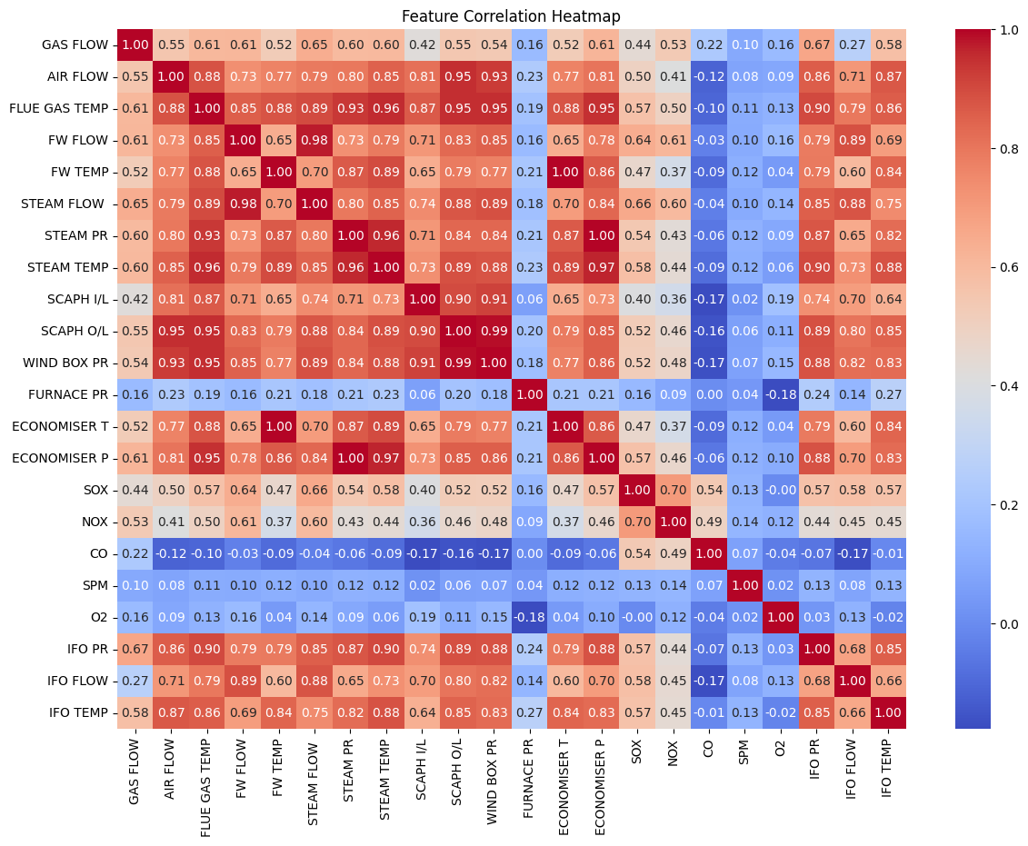

* **Scatter Plot Visualization:**

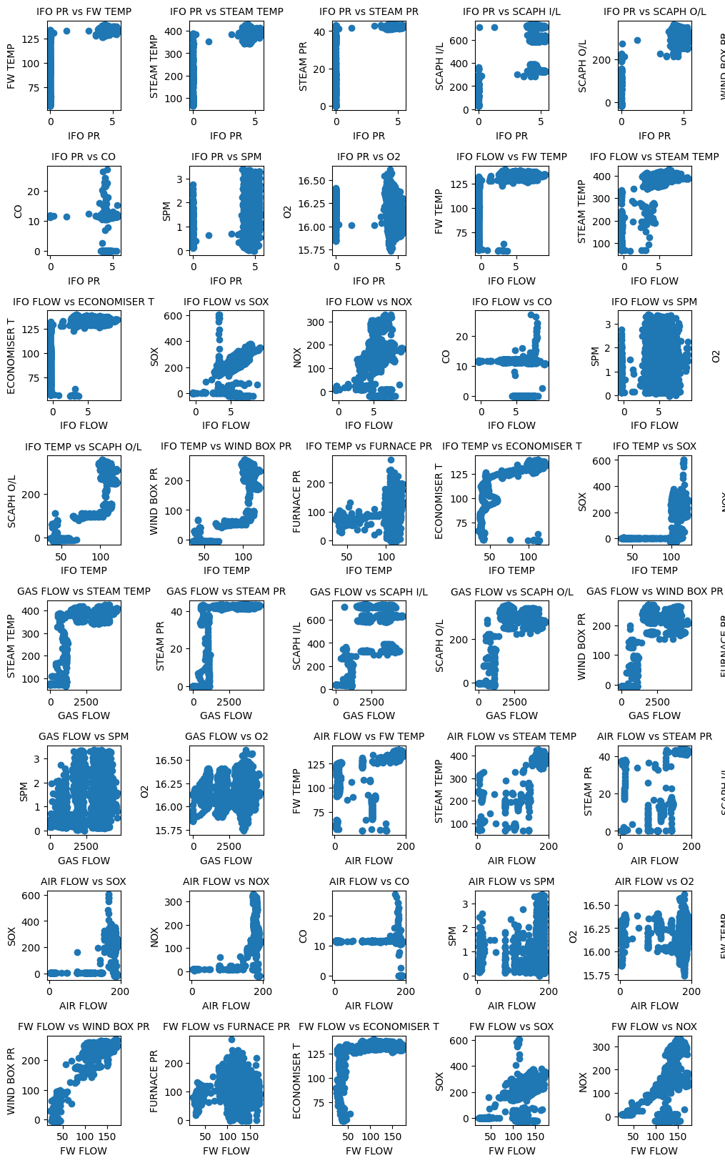

**APC Benefit Estimation Methodologies**

Advanced Process Control (APC) systems are designed to enhance efficiency and profitability in industrial processes by reducing variability and optimizing operations. The estimation of benefits from APC implementation involves several methodologies to quantify potential savings and improvements. These methodologies typically include:

1. **Best Operator Method**

* Description: Assumes the APC system can consistently operate as well as the best human operator.
* Estimation: Savings are calculated based on the difference between the average operating point and the best operator's point.

1. **Same Percent Limit Violation Method**

* Description: Calculates the shift in the average operating point, assuming the APC system can violate a limit the same percentage of time as the current manual operation.
* Estimation: Based on maintaining the same rate of limit violations while shifting the average closer to the limit.

1. **Same Percent Violation of the 5% Limit Method**

* Description: Uses a more realistic limit that is exceeded by only 5% of the data when the actual limit is unclear or not well-defined.
* Estimation: Calculates the shift in the average based on this 5% limit.

1. **Limit Violation a% of Time Method**

* Description: Assumes the limit can be violated a certain percentage of the time with APC when the limit is rarely or never violated in current operations.
* Estimation: Calculates the shift in the average accordingly.

**Same Percent Limit Violation Method in Detail**

The Same Percent Limit Violation Method is a statistical approach that estimates the potential benefits of APC by considering the current rate of limit violations. It assumes that the APC system can maintain the same rate of violations while potentially shifting the average operating point closer to the limit. Here’s how it works:

1. **Data Collection**
   * Collect historical data on the process variable of interest, such as product quality or a manipulated variable.
2. **Statistical Analysis**
   * Perform a statistical analysis to determine the mean (average) and standard deviation of the process variable. This helps understand current variability and the frequency of limit violations.
3. **Normal Distribution Assumption**
   * Assume the data fits a normal (Gaussian) distribution, allowing the use of standard statistical tables and formulas to estimate the probability of limit violations.
4. **Determining Current Violation Rate**
   * Calculate the percentage of time the current process violates the specified limit using the standard normal distribution function and the process variable's mean and standard deviation.
5. **Estimating New Average**
   * Estimate the new average operating point based on the assumption that the APC system can maintain the same percentage of limit violations. This involves shifting the average closer to the limit.
6. **Calculating Benefits**
   * With the new average operating point, calculate the potential benefits, including evaluating the impact on product quality, yields, and energy consumption, and translating these into monetary savings.
7. **Considering Process Constraints**
   * Ensure that the shift in the average operating point does not violate any process constraints or safety limits.

This method is considered more liberal than the Best Operator Method because it allows for a shift in the average operating point, assuming the APC system can perform at least as well as the current manual operation in terms of limit violations. It is commonly used for estimating benefits in cases where product quality specifications are involved.

**References:** <https://www.emersonautomationexperts.com/papers/EstimatingBenefitsfromAdvancedControl.pdf>

1. **Potential Benefits: XIRR and IRR**:

Implementing Advanced Process Control (APC) systems can lead to several economic benefits, including improvements in process efficiency, product quality, and overall operational performance. Two key financial metrics that can help quantify these benefits are the Internal Rate of Return (IRR) and the Extended Internal Rate of Return (XIRR).

1. **Internal Rate of Return (IRR)**:

The IRR is a financial metric used to measure the profitability of an investment. It is the discount rate that makes the net present value (NPV) of all cash flows from a project equal to zero. In the context of APC, the IRR can be used to evaluate the return on investment (ROI) of implementing such systems.

1. **Extended Internal Rate of Return (XIRR)**:

The XIRR is a more sophisticated version of the IRR that considers the timing of cash flows. It is particularly useful for projects with irregular cash flow patterns, which is often the case with APC implementations. The XIRR provides a more accurate measure of the investment's profitability by considering the exact dates of cash inflows and outflows.

1. **Calculation and Interpretation:**

* **IRR Calculation**: The IRR is typically calculated using financial software or spreadsheet tools like Microsoft Excel. The formula for IRR in Excel is **=IRR (values)**, where **values** is the range of cells containing the cash flows.
* **XIRR Calculation**: The XIRR formula in Excel is **=XIRR (values, dates)**, where **values** is the range of cells containing the cash flows and **dates** is the range of cells containing the corresponding dates.

1. **Potential Benefits:**

* **Improved Process Efficiency**: APC systems can reduce process variability, leading to more consistent product quality and reduced waste. This can result in significant cost savings and increased throughput.
* **Enhanced Product Quality**: By maintaining tighter control over process variables, APC systems can help ensure that products meet specifications more consistently, reducing the risk of defects and rework.
* **Energy and Resource Savings**: APC systems can optimize energy and resource usage, leading to reduced operating costs and environmental benefits.
* **Increased Safety**: APC systems can monitor and respond to process upsets more quickly and effectively than human operators, improving overall plant safety.
* **Financial Metrics**: The IRR and XIRR can provide a clear indication of the financial viability of an APC project, helping companies make informed investment decisions.

1. **Limitations:**

While APC systems offer numerous benefits, there are also several limitations to consider:

* **High Initial Investment**: Implementing APC systems requires a significant upfront investment in hardware, software, and personnel training.
* **Complexity**: APC systems can be complex to design, implement, and maintain, requiring specialized knowledge and expertise.
* **Dependency on Accurate Data**: The effectiveness of APC systems is highly dependent on the accuracy and reliability of the data used. Inaccurate data can lead to suboptimal control strategies.
* **Integration Challenges**: Integrating APC systems with existing plant infrastructure can be challenging and may require significant modifications to existing processes and equipment.
* **Maintenance and Support**: APC systems require ongoing maintenance and support to ensure they continue to operate effectively. This can be a significant ongoing cost.
* **Resistance to Change**: Operators and management may resist changes to established operating procedures, which can hinder the successful implementation and adoption of APC systems.
* **Uncertainty in Benefits Estimation**: The estimation of benefits from APC systems can be uncertain, especially in complex processes with many variables. The actual benefits may vary from the estimated values.

In summary, while APC systems offer significant potential benefits, it is important to carefully consider the limitations and challenges associated with their implementation. A thorough cost-benefit analysis using metrics like IRR and XIRR can help companies make informed decisions about investing in APC technologies.

**Conclusion**

My internship at Indian Oil Corporation Limited (IOCL) Panipat Refinery has significantly enhanced my understanding of Advanced Process Control (APC) systems in boiler operations. I focused on designing APC parameters, developing model matrices, and proposing robust network architectures to optimize boiler performance.

This experience demonstrated the critical role APC plays in improving combustion efficiency, maintaining water chemistry, and ensuring operational stability. Working closely with the engineering team, I gained practical insights into steam scavenging, TSP and morpholine dosing, and various control mechanisms such as steam separators, superheaters, demisters, deaerators, and blowdown systems.

The comprehensive report I am submitting details my findings and includes practical examples and data to illustrate the impact of APC in boiler systems. This internship has improved my technical skills and strengthened my analytical and problem-solving abilities, preparing me for future challenges in chemical engineering. I am grateful for the opportunity to learn from and contribute to the team at IOCL Panipat Refinery and look forward to applying this knowledge in my career.